**Ideation Phase**

**Define the Problem Statements**

|  |  |
| --- | --- |
| Date | 13 October 2022 |
| Team ID | PNT2022TMID36166 |
| Project Name | Classification of Arrhythmia by Using Deep Learning with 2-D ECG Spectral Image Representation |
| Maximum Marks | 2 Marks |

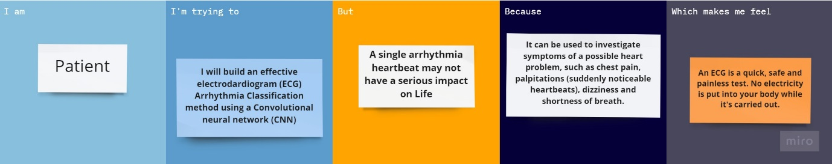

|  |  |  |  |  |  |
| --- | --- | --- | --- | --- | --- |
| **Problem Statement (PS)** | **I am (Customer)** | **I’m trying to** | **But** | **Because** | **Which makes me feel** |
| PS-1 | Patient | I will build an effective electrocardiogram (ECG) Arrhythmia classification method using a convolutional neural network (CNN). | A single arrhythmia heartbeats may not have a serious impact on life. | It can be used to investigate symptoms of a possible heart problem, such as a chest pain, palpitation, dizziness and shortness of breath. | An ECG is a quick, safe and painless test.no electricity is put into your body while it’s carried out. |
| PS-2 | Patient | I am trying to cure the cardiovascular diseases (CVDs). | Arrhythmia is a representative type of CVD that refers to any irregular change from the normal heart rhythms. | Over 17.7 million people died from CVDs in the year 2017.The world wise the count of deaths percentage is 31%. | Arrhythmia using deep two-dimensional CNN with grayscale ECG images. |